SOP: First-Time Deployment of a New Application to the Operations Center
Document ID: OPS-SOP-NEWAPP-001
Applies to: All DevNest product teams and Platform Ops
Environment: DevNest Cloud (prod + pre-prod)
Change Type: Net-New Application Onboarding
Risk Tier: Defaults to Tier-1 until assessed; Tier-0 requires CRO sign-off.

1) Purpose
Process for onboarding and deploying a new application into DevNest production environment, ensuring:
- Safe integration with shared services
- Validated blast radius and dependency accuracy
- Audit-defensible change management
- Operational readiness including monitoring, runbooks, KRIs, and ownership

2) Scope
Cvers the first ever deployment of a new product service or microservice group into:
- Production
- Pre-production environments that are production-connected
  - e.g., shared NoSQL, shared IAM
- Does not apply to routine deployments to an already-onboarded application.
  - Those follow OPS-SOP-DEPLOY-002.

3) Roles & Responsibilities (RACI)
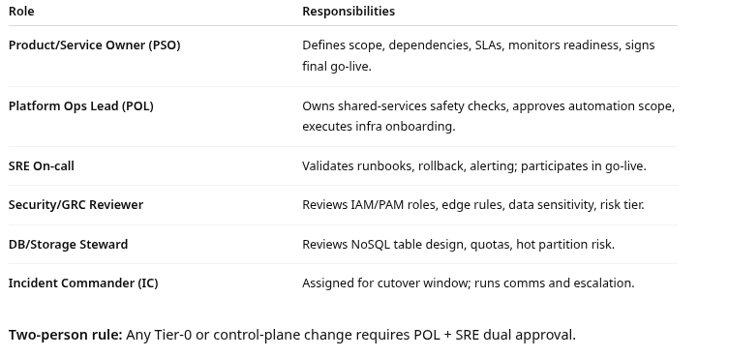

4) Preconditions / Entry Criteria
All items must be complete before scheduling Day-0 deployment.

4.1 Documentation
- Application scope + owner documented in Service Catalog.
- Dependency Map completed and reviewed by Platform Ops.
- Risk Tier assigned (Tier-1 default; Tier-0 if systemic).
- Runbook v1 drafted (startup/shutdown, health checks, rollback, common errors).
- Support boundaries defined (what Ops vs Product handles).
- SLA/SLO targets proposed.

4.2 Technical Readiness
- Code in main branch with CI passing.
- Container images built and scanned.
- IaC (Terraform/CloudFormation) reviewed and merged.
- Service tags validated (see §6).
- IAM roles created, least-privilege verified.
- NoSQL tables/streams provisioned with quotas reviewed.
- Edge/WAF baseline ruleset approved.
- Observability instrumentation (logs/metrics/traces) integrated.

5) Change Management Requirements
- Change ticket required in ChangeHub:
  - Type: Net-New Application
  - Risk tier, blast radius, rollback plan mandatory
- Peer review mandatory
  - If emergency override is used → deployment is blocked pending CRO approval
- Change window
  - New apps deploy only during standard window unless Tier-0 incident case

6) Tagging & Automation Safety (Critical)
Because DevNest automation scopes by tags, incorrect tagging can create systemic blast radius.

6.1 Required tags for new apps
Every new service must have:
- product.<line-of-business> (e.g., product.commerce)
- tier.<0|1|2> (temporary Tier-1 until assessment)
- platform.shared=false
- automation.scope=app-only (blocks controlplane rollouts)
- owner.<team>

6.2 Forbidden tags for new apps
Do not apply any of these:
- controlplane.*
- platform.shared
- critical.tier0 (unless approved)

6.3 Tag validation step
Platform Ops must run:
- scope-lint inventory.yaml --service <newapp>
- automation-dryrun --tags <newapp tags>
Exit criterion: Dry run must show only the new app in scope.

7) Step-By-Step Procedure

Phase 1: Intake & Scoping (T-10 to T-5 business days)
- Submit Net-New Application Onboarding Form
  - app name + owner
  - intended LOB
  - risk tier proposal
  - dependency list
  - data classification
- Platform Ops review meeting
  - validate shared-service dependencies
  - confirm tag set
  - identify systemic collision risks
- Security/GRC review
  - IAM roles, PAM needs, edge exposure, data sensitivity
- Storage review
  - NoSQL design, indexes, quota, expected R/W patterns
- Approve move to pre-prod onboarding
Output: Approved onboarding plan + change ticket opened.

Phase 2: Pre-Production Onboarding (T-5 to T-2)
- Provision infrastructure via IaC
  - VPC/net permissions
  - compute (K8s namespace/ECS service)
  - NoSQL tables/streams
  - secrets in vault
- Register service in DNS/Discovery
  - create app-scoped discovery records
  - validate records resolve to test endpoints
- Configure Edge/WAF (pre-prod)
  - baseline ruleset
  - rate limiting thresholds
  - bot score/challenge parameters
- Integrate IAM
  - workforce/admin roles
  - service-to-service token policies
- Instrument Observability
  - service dashboards created
  - SLO alerts configured
  - logs searchable in central stack
- Run pre-prod deployment
  - cicd deploy --env preprod --scope app-only
Exit criteria
- pre-prod health checks green
- edge/WAF rules stable
- NoSQL throughput within bounds
- dashboards show correct signals
- rollback tested once in pre-prod

Phase 3: Go-Live Readiness Review (T-2 to T-1)
- Operational Readiness Review (ORR)
  - PSO + POL + SRE + Security in 45-min gate
- Confirm:
  - runbook v1 complete and accessible
  - on-call rotation defined
  - escalation paths confirmed
  - KRIs/KPIs defined (see §9)
  - rollback plan real and time-boxed
- Approve production window
Output: ORR approval recorded in change ticket.

Phase 4: Production First Deployment (Day 0)
Participants on bridge: Primary Service Owner, Primary Operations Lead, SRE on-call, IC, Security on standby
- Start change bridge
  - IC opens incident channel (even if not an incident)
  - POL confirms scope lint passed
- Freeze unrelated deploys in same LOB for window
- Deploy to production
  - cicd deploy --env prod --scope app-only
- Validate service discovery
  - check internal DNS resolution
  - verify no cross-service record edits
- Validate edge/WAF
  - confirm ruleset version matches approved SHA
  - run synthetic traffic tests
- Health checks
  - app liveness/readiness
  - dependency calls to IAM, NoSQL
- Enable traffic gradually
  - 5% → 25% → 50% → 100%
  - observe retries, latency, throttling
- Declare stable
  - 30 minutes at 100% traffic without SLO breach
Exit criterion: PSO + POL sign go-live complete.

Phase 5: Post-Deployment Monitoring (Day 0 to Day 7)
- Enhanced monitoring mode (72 hrs)
  - no config changes without POL approval
- Daily health check summary to Ops Center
  - key KRIs / incidents / anomalies
- Week-1 retrospective
  - confirm risk tier finalization
  - tune alerts/thresholds
  - update run-book v1 → v1.1

8) Rollback Procedure (First Deployment)
Rollback must be executable even if Identity or Edge are degraded.
- Trigger rollback if any are true:
  - P1 incident declared
  - sustained 5xx > threshold
  - NoSQL throttling rising continuously
  - auth failures > 2× baseline
- Rollback command
  - cicd rollback --env prod --service <newapp> --scope app-only
- Disable edge routing
  - revert edge ruleset to previous stable version
- Validate dependency stability
  - confirm no DNS drift
  - confirm NoSQL recovery trend
- Post-rollback comms
  - IC posts summary and time to restore
Rollback must complete in ≤15 minutes for Tier-0 services, ≤30 minutes Tier-1.

9) Required KRIs/KPIs (First-Week Set)
New apps must publish and alert on minimum KRIs:
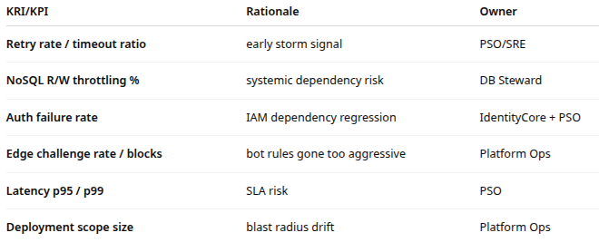
Thresholds must be documented in runbook.

10) Evidence & Audit Artifacts
Ops Center retains:
- change ticket + approvals
- ORR checklist
- tag lint report
- CI/CD run logs for deploy + rollback test
- edge ruleset SHA
- NoSQL provisioning plan
- dashboards + alert definitions
- week-1 retrospective action list

11) Common Failure Modes & Mitigations
- Mis-tagging Appendix: ORR Checklist (Quick Form)
- Scope
- Service catalog entry complete
- Dependency map validated
- Risk tier assigned
- Safety
- Tags validated + no forbidden tags
- Automation dry run clean
- Two-person approval if Tier-0includes controlplane scope
  - mitigated by mandatory lint + dry run
- NoSQL hot partitions during ramp-up
  - mitigated by staged traffic + quota review
- Edge rules overly strict
  - mitigated by pre-prod synthetic tests + gradual enablement
- Monitoring blind spots
  - mitigated by ensuring telemetry survives NoSQL degradation
- Rollback depends on SSO
  - mitigated by break-glass + out-of-band tooling

12) Appendix: Operational Readiness Review Checklist
Scope
- Service catalog entry complete
- Dependency map validated
- Risk tier assigned
Safety
- Tags validated + no forbidden tags
- Automation dry run clean
- Two-person approval if Tier-0
Operations
- Runbook v1 complete
- On-call ownership confirmed
- Rollback tested in pre-prod
Monitoring
- Dashboards created
- KRIs/KPIs defined with thresholds
- Alerts route to correct on-call
Sign-offs
- PSO (Product Service Owner)
- POL (Platform Operations Lead)
- SRE (Site Reliability Engineering)
- Security

